**Exp. 20 Database as a Service**

**Aim:**

To demonstrate Database as a Service (DaaS) create and configure a new VM Image in any Public Cloud Service Provider.

**Procedure:**

* Sign in to Azure Portal
* Create a resource group
* Create a VM
* Open the VM by entering username and password
* Install MySQL (Server only) inside the VM
* Now the database is ready.

**Output:**

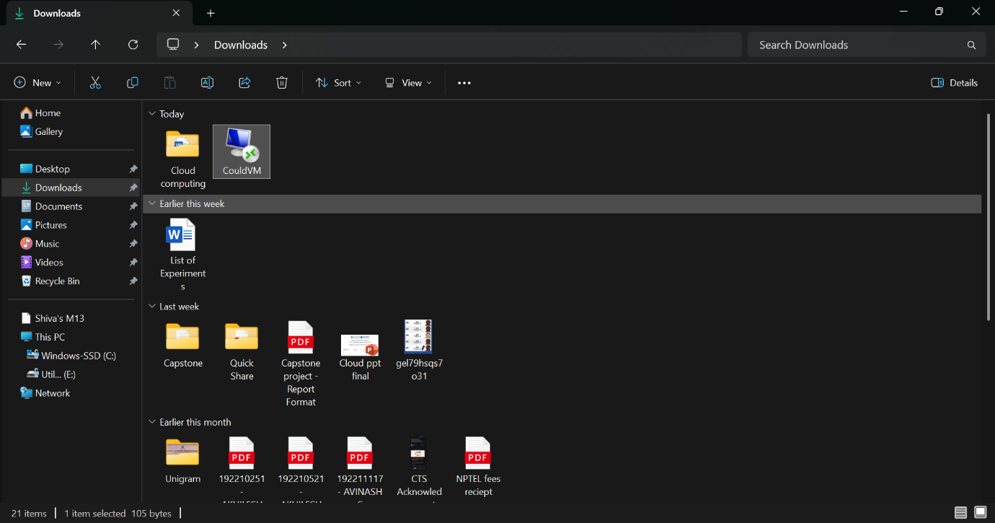

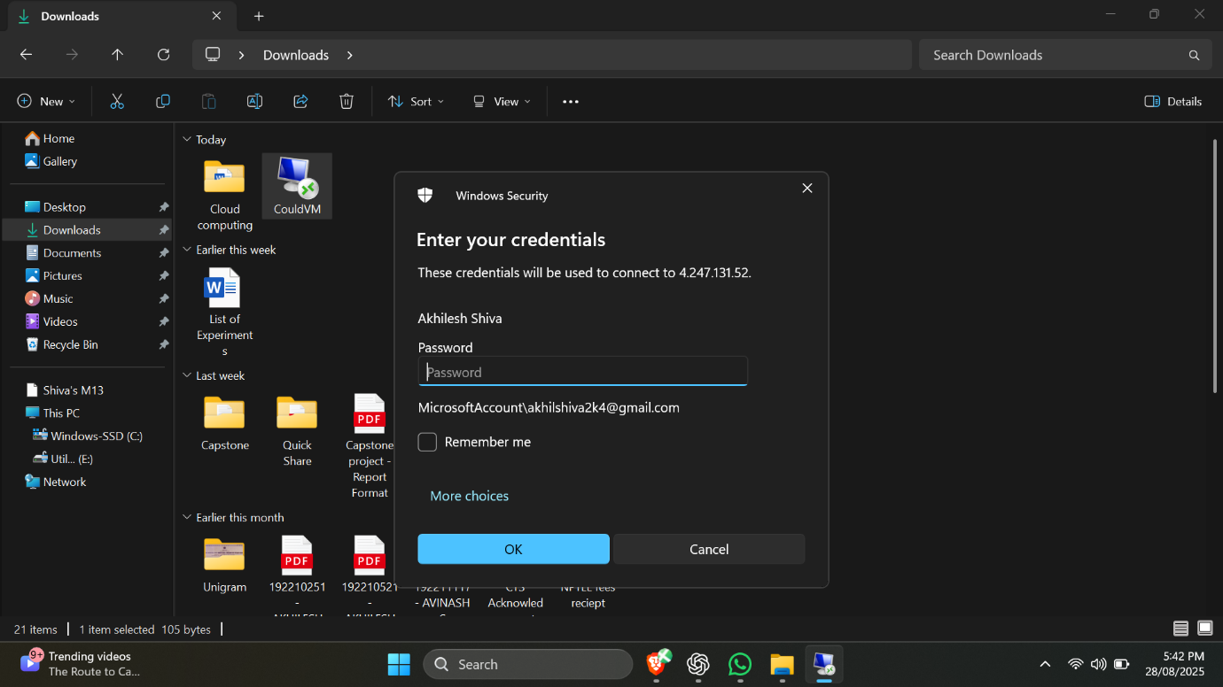

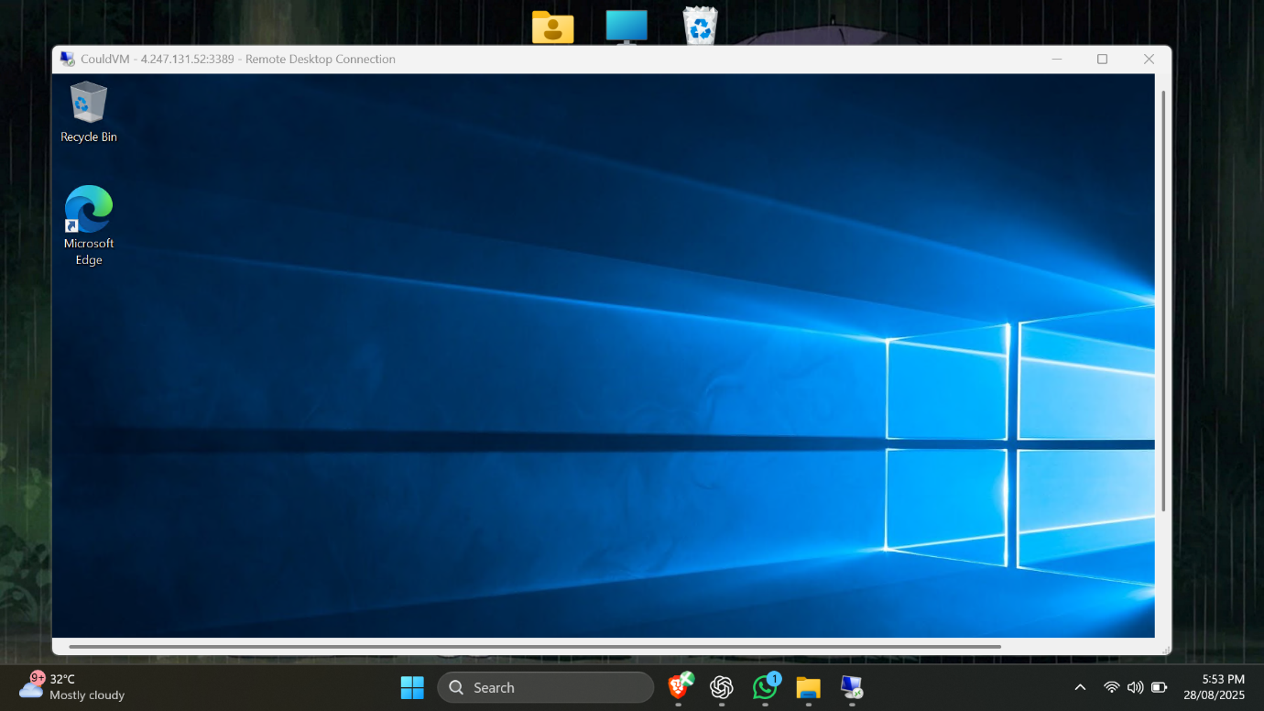

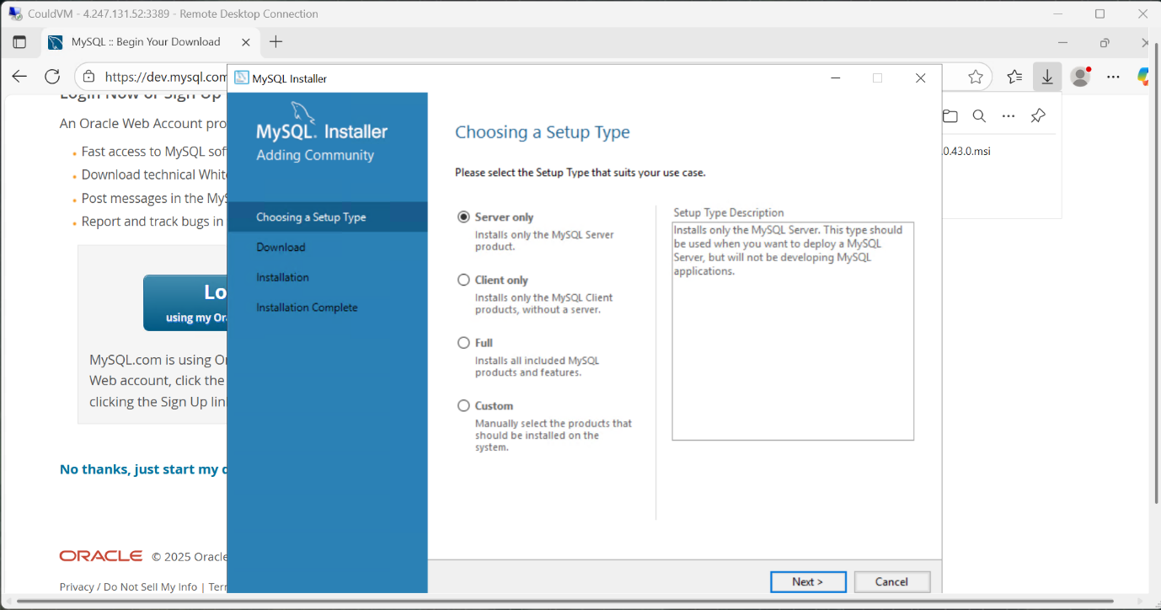

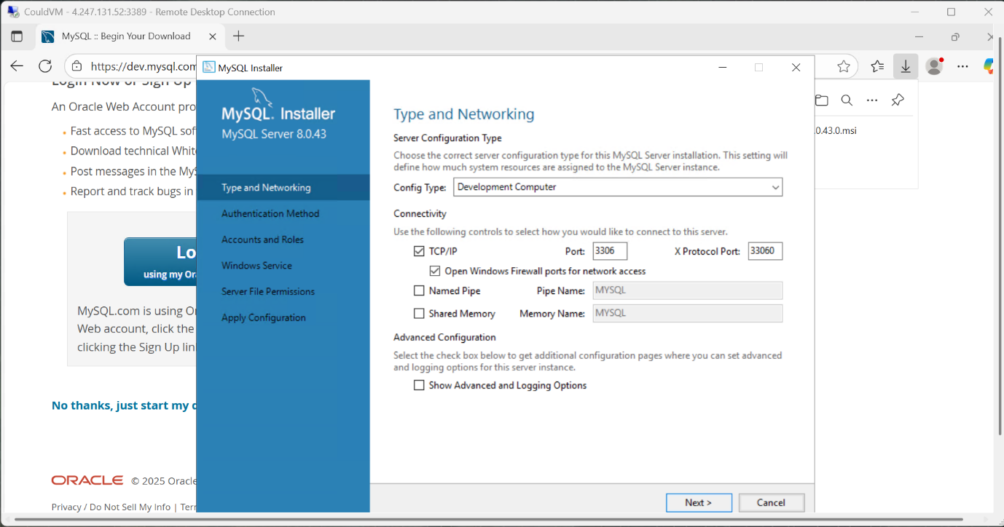

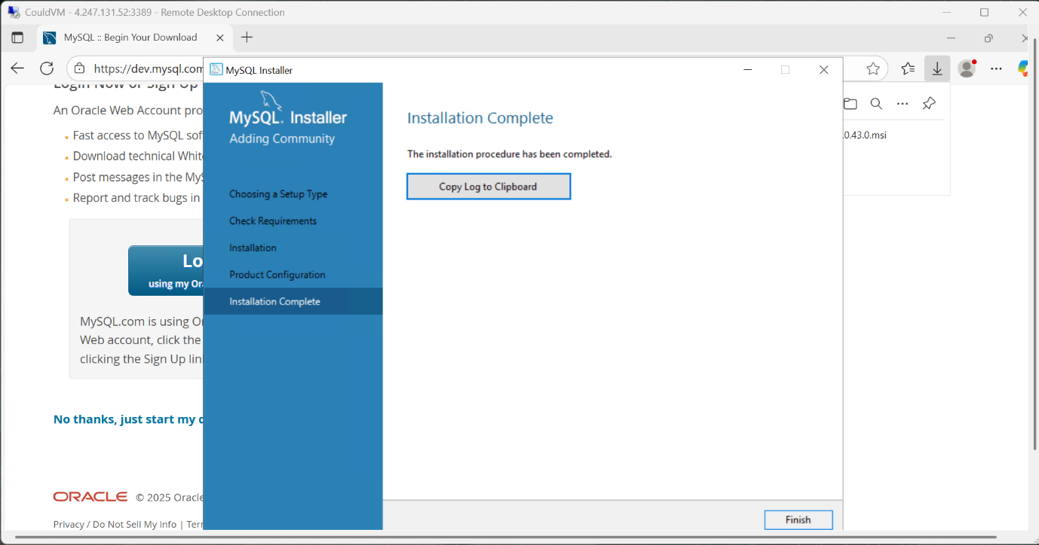

**Result:**

Thus, the storage service was created successfully